**Poison Smart Kids**

**Coloring Sheets**

**The Oklahoma Poison Center**

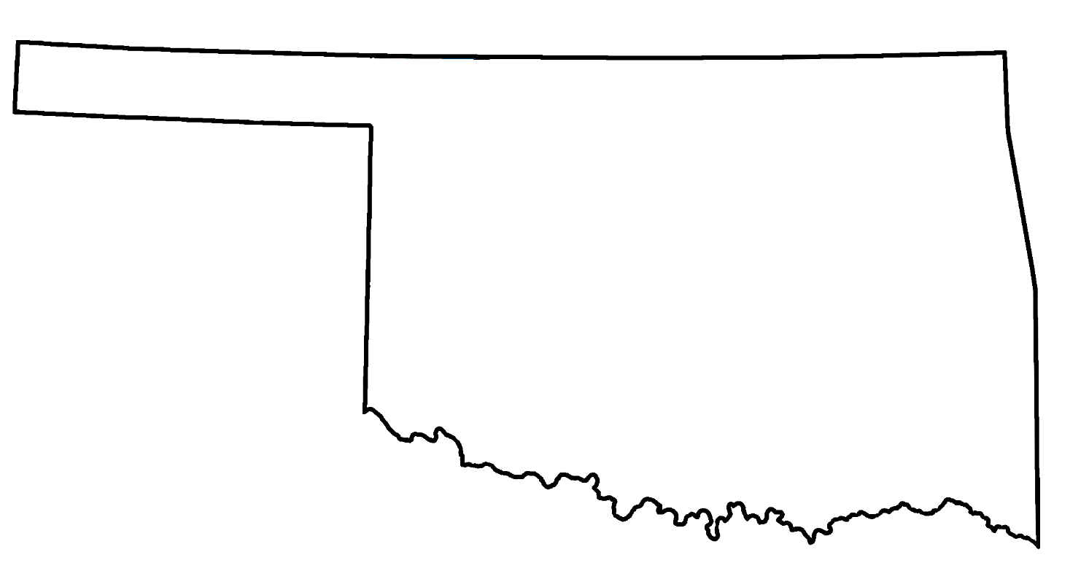

**Note to Parents and Grown-ups:**

**Dear Parents and Grown-ups:**

**At the Oklahoma Center for Poison & Drug Information, we aim to encourage children to make discoveries in a safe and responsible way. No matter what age, your child can learn that the best thing to do is to ask a grown-up before he or she touches, tastes, or smells!**

**Please take some time to go through these coloring sheets with your child and add our phone number to your phone:**

**1-800-222-1222. There are qualified specialists available 24/7, 365 days a year to answer your poison and drug information questions!**

**Sincerely,**

**Your friends**

**The Oklahoma Poison Center**

**Poison Smart Kids: ASK FIRST!**

**Medicine is not candy!**

**Sometimes medicine looks yummy.**

**Sometimes medicine looks like candy!**

**How do you know if it is safe to taste???**

**ALWAYS ASK A GROWN-UP BEFORE YOU**

**TASTE, TOUCH, OR SMELL!**

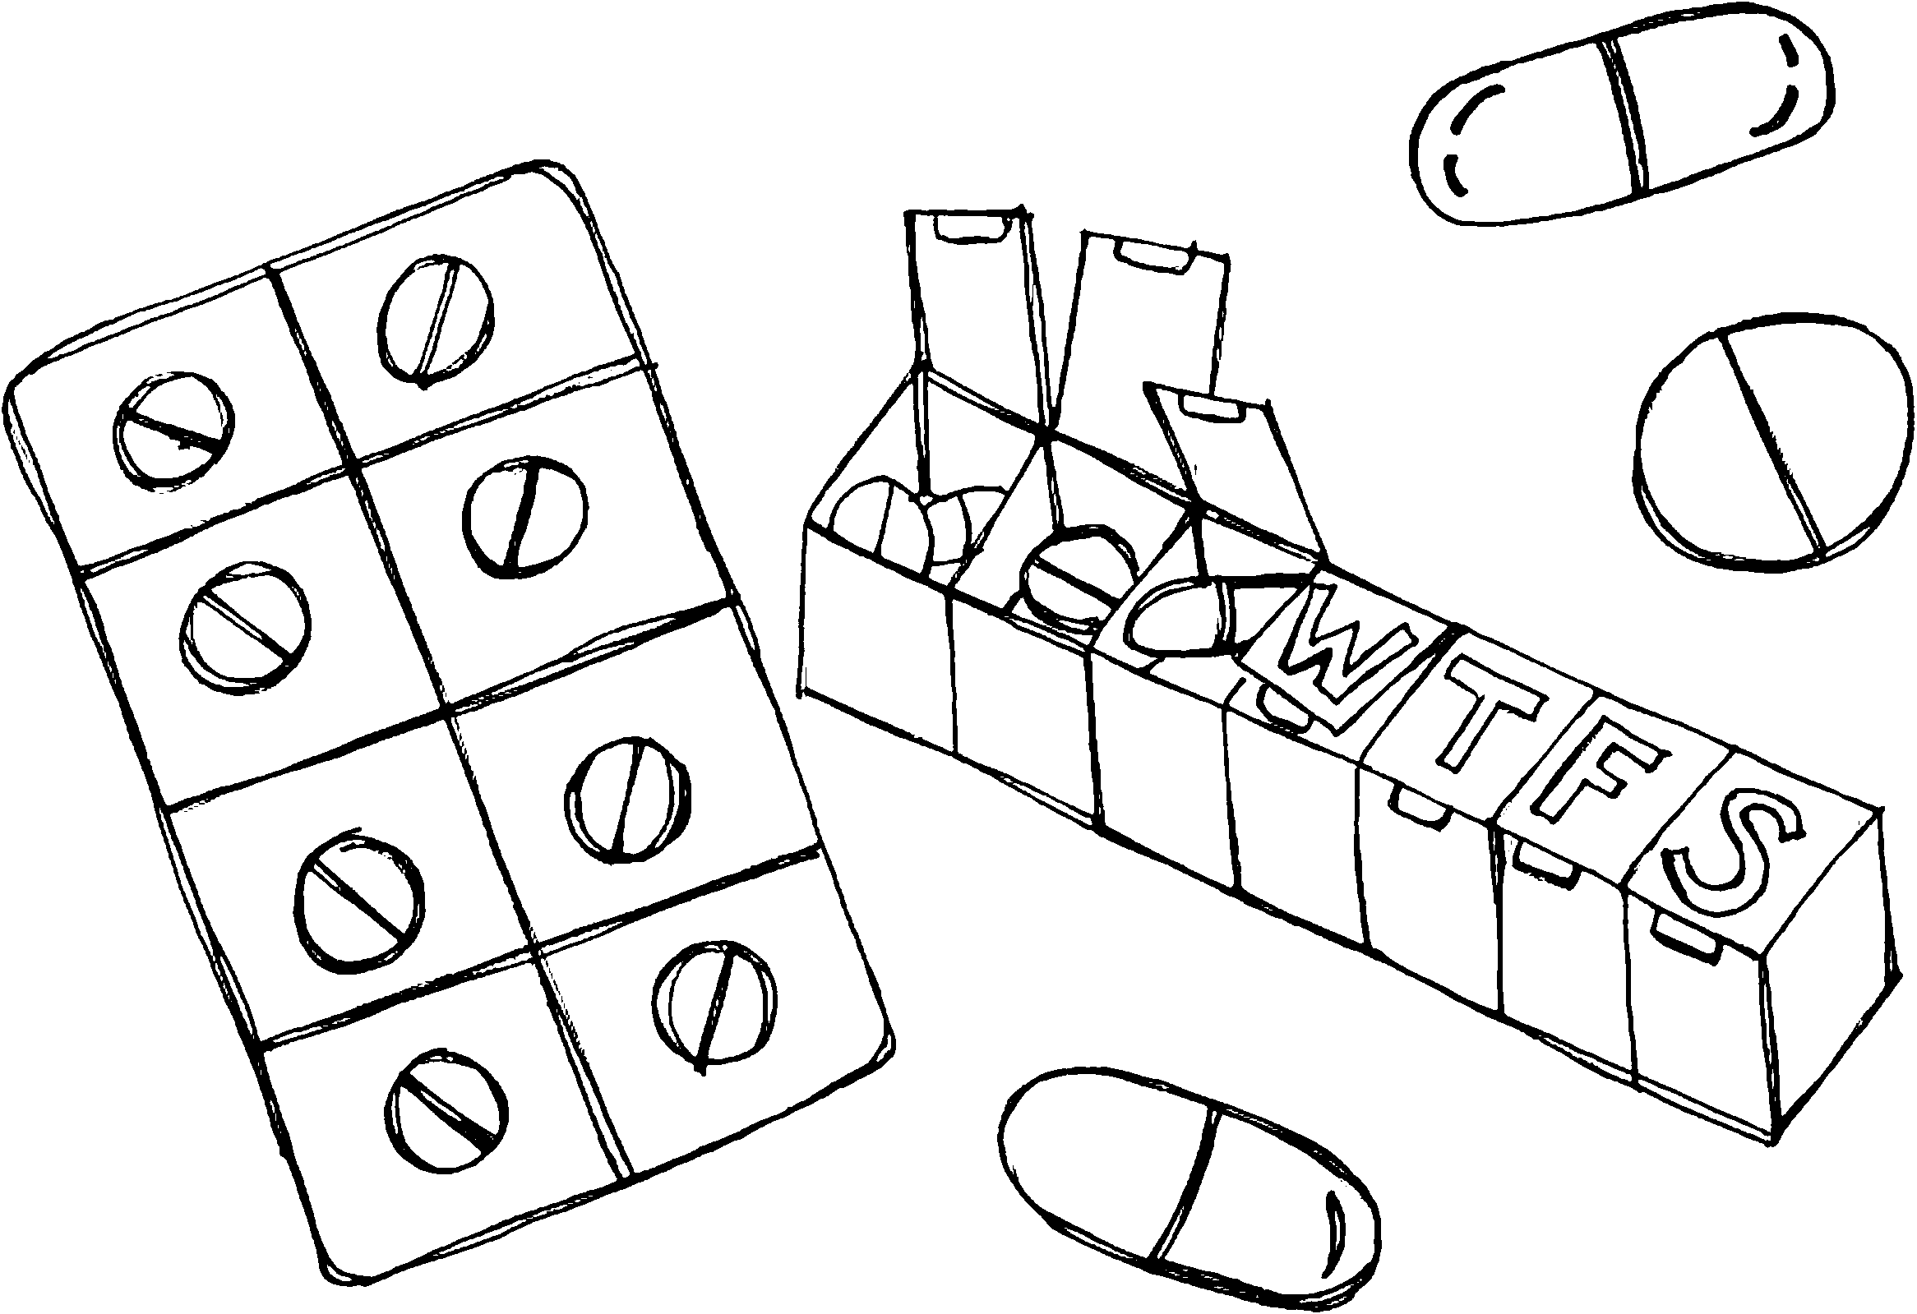

**Poison Smart Kids: ASK FIRST!**

**Cleaning supplies are not for kids!**

**Sometimes grown-ups clean with colorful sprays and bottles, but they have to be careful when they do.**

**These are only for grown-ups!**

**Ask a grown-up how you can help clean safely!**

**ALWAYS ASK A GROWN-UP BEFORE YOU**

**TASTE, TOUCH, OR SMELL!**

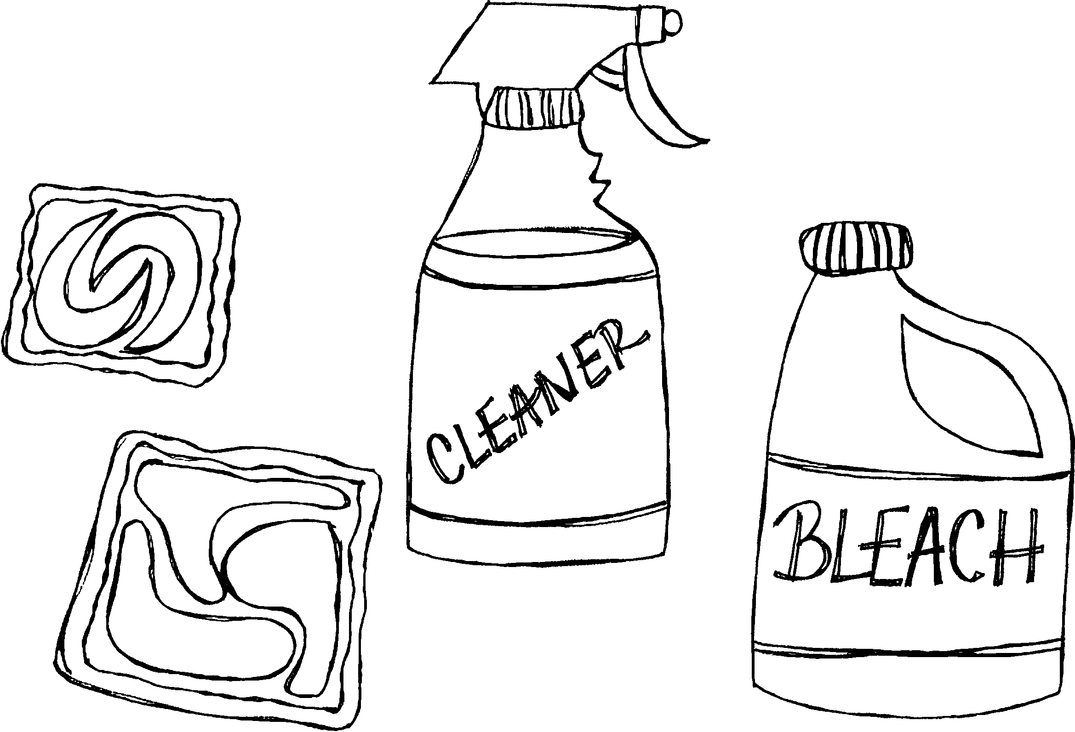

**Poison Smart Kids: ASK FIRST!**

**You are already poison smart!**

**You use things every day the right way!**

**Now you know:**

**ALWAYS ASK A GROWN-UP BEFORE YOU**

**TASTE, TOUCH, OR SMELL!**

**Circle the items below that are poisonous. Ask a grown-up to help you if you don’t know what something is!**

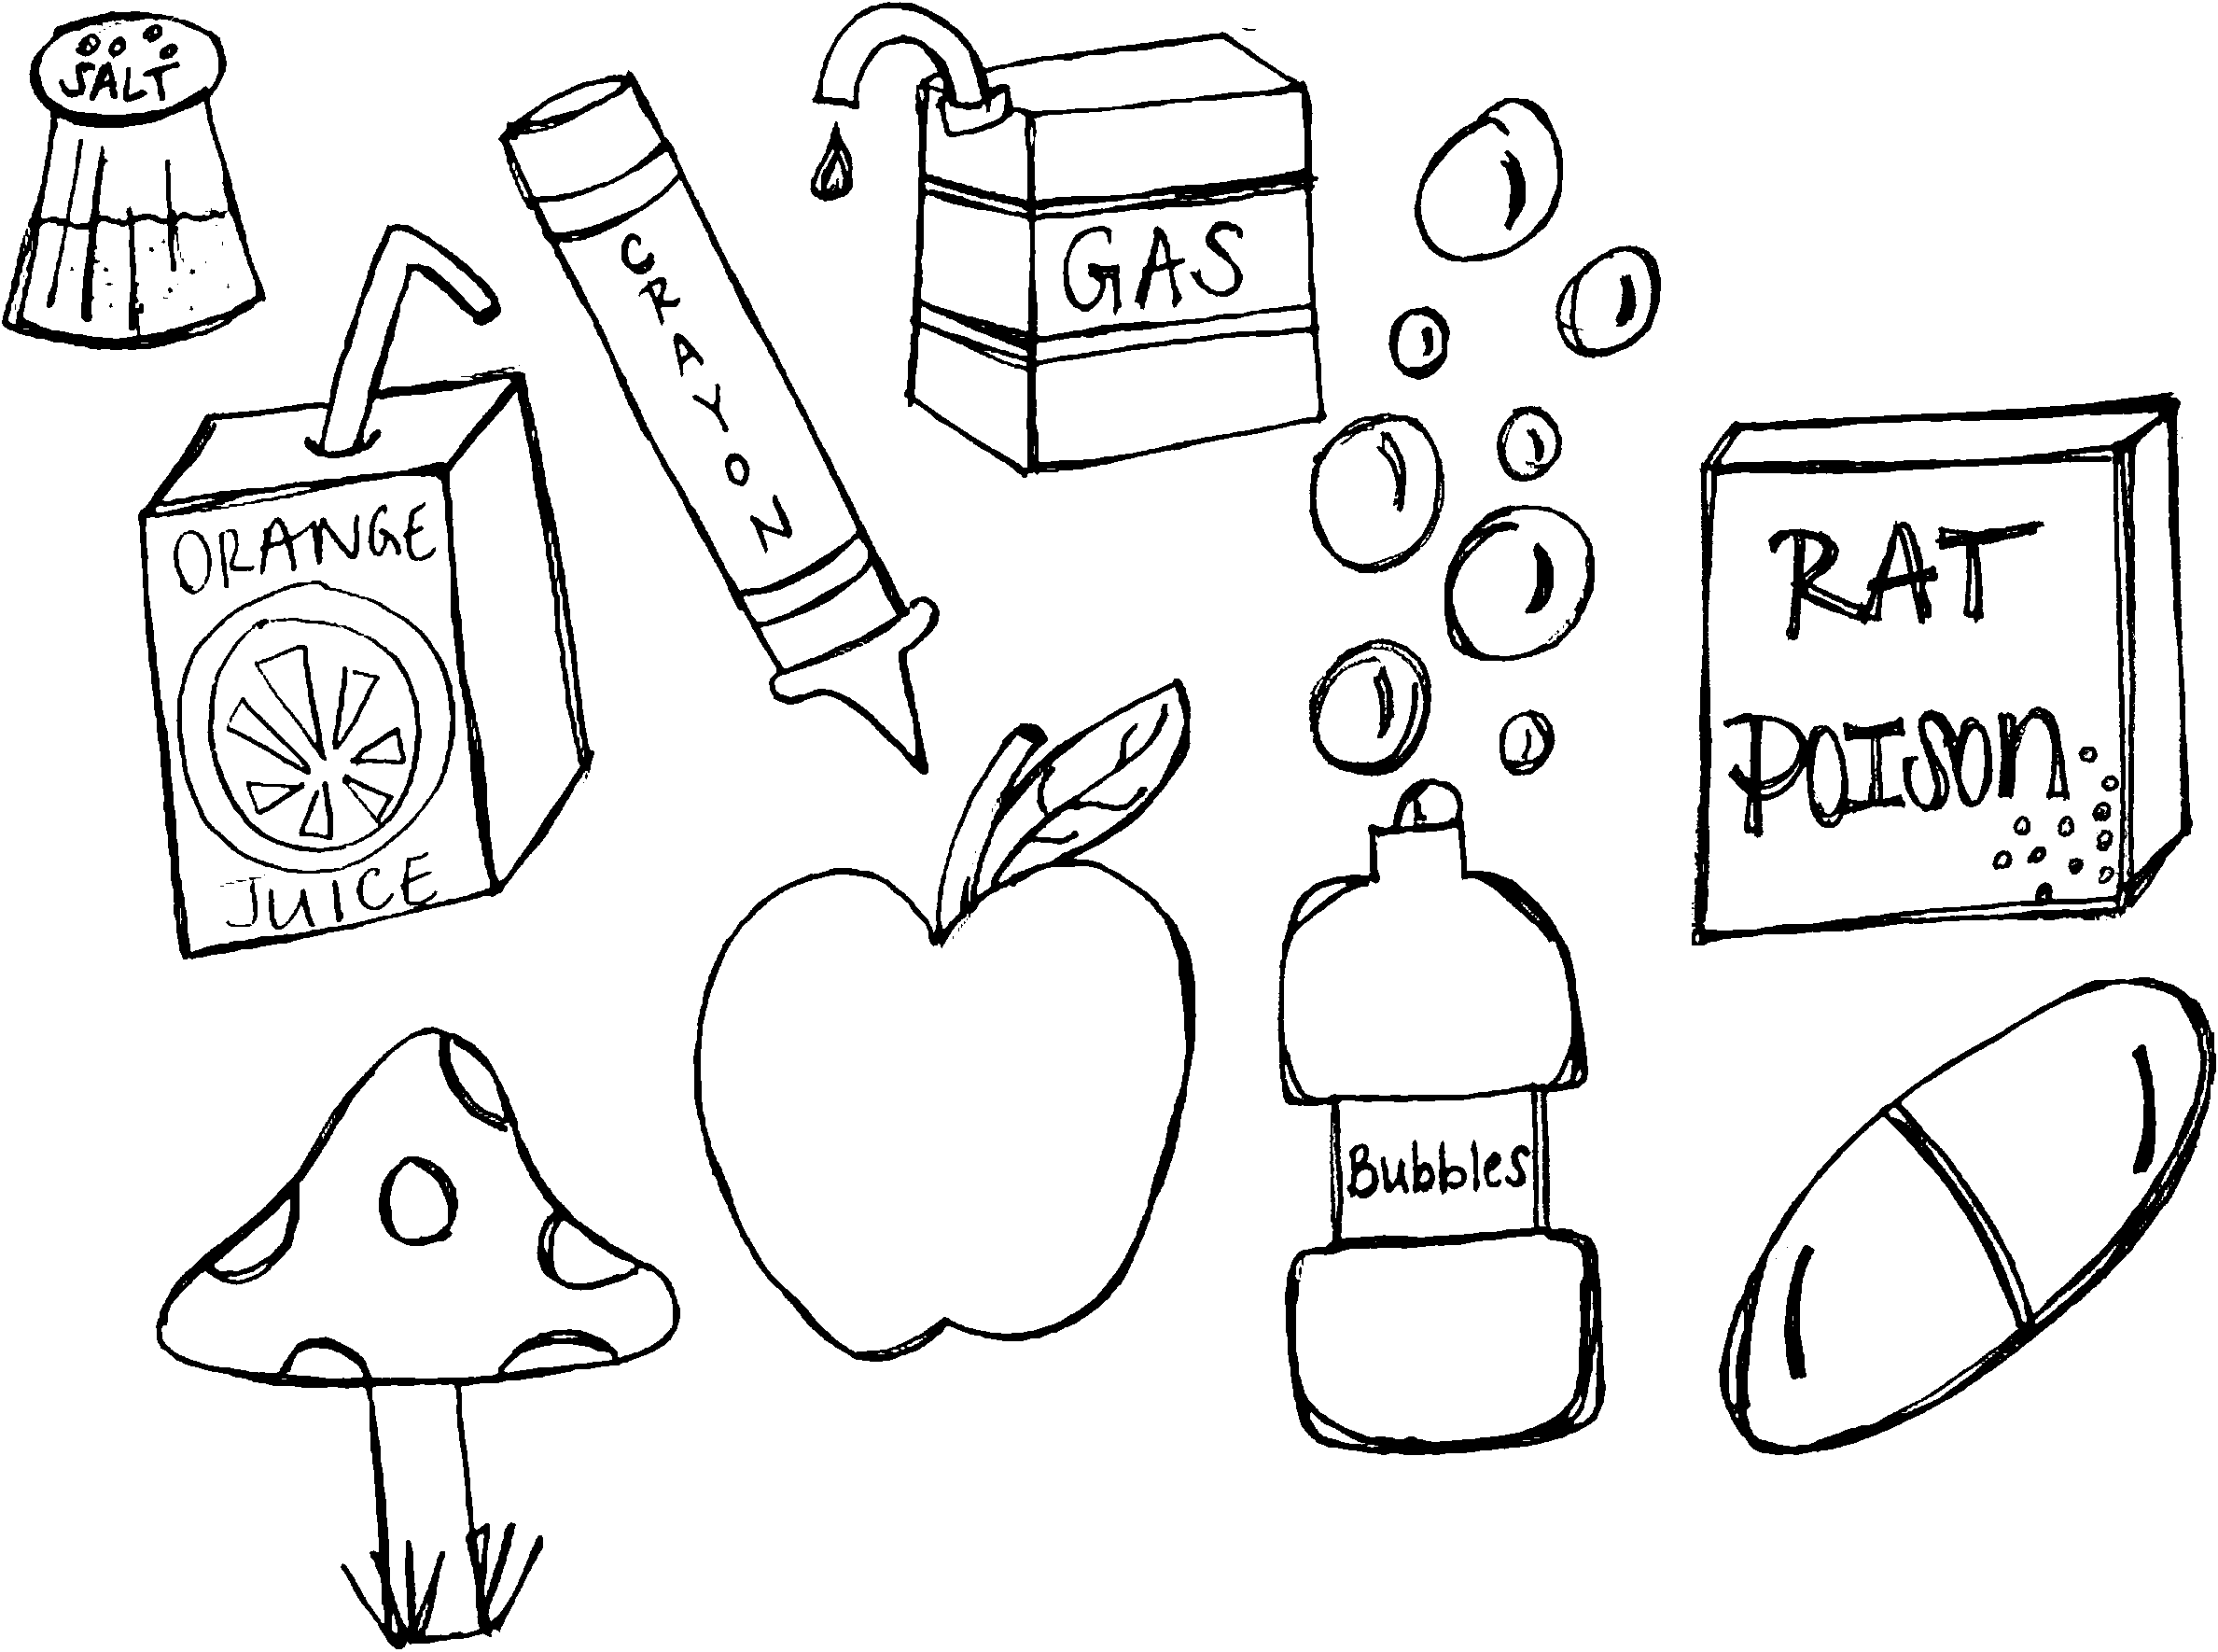

**Rat poison, mushroom, salt, medicine, gas**

**Save our number in your phone.**

**Trace the number!**

**Then, you can color and cut it out!**

**(800)**

  

 

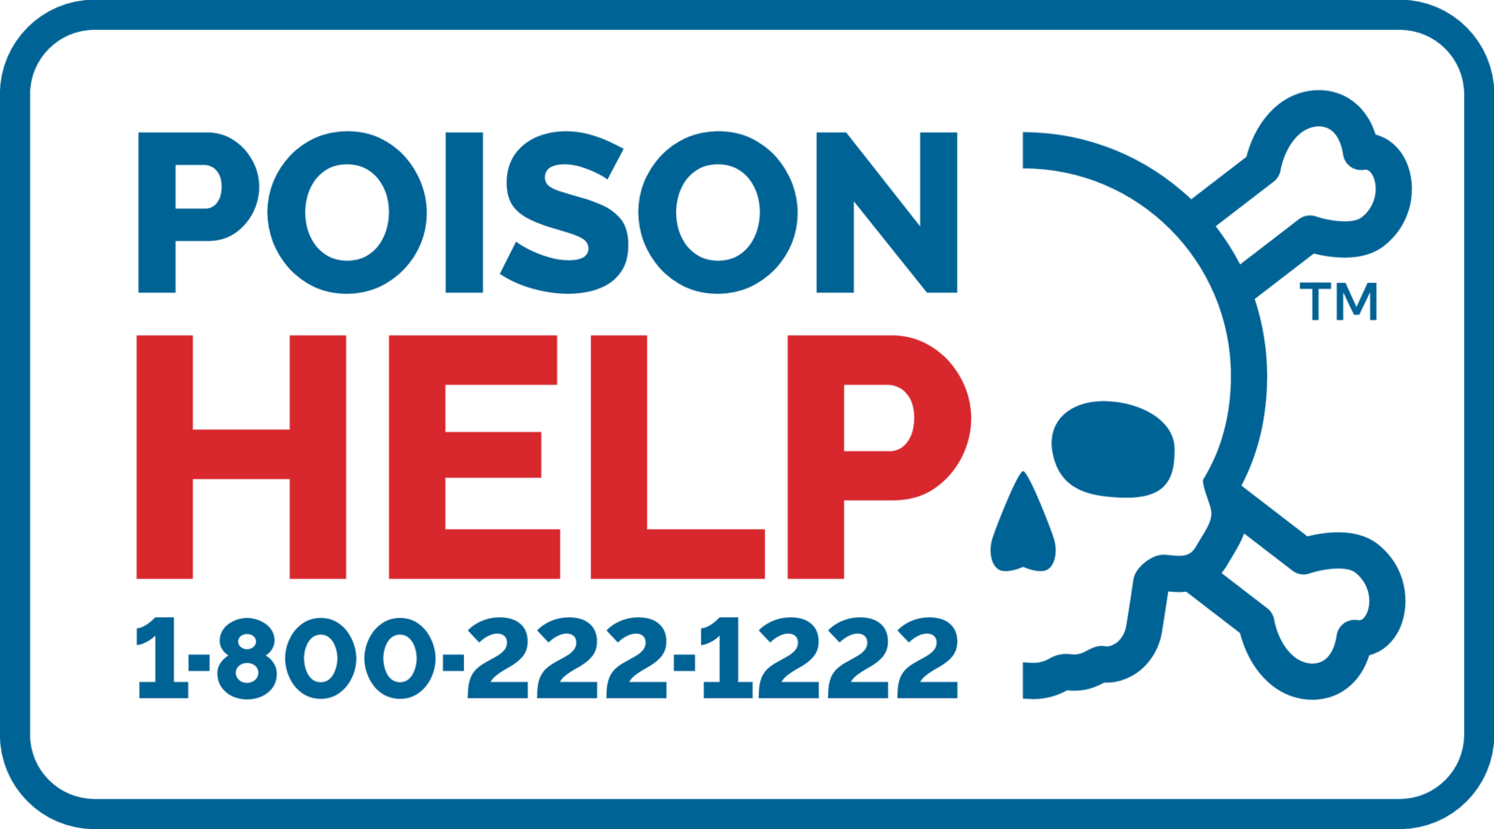

**Poison Smart Kids: YOU DID IT!**

**Now you know to ASK FIRST before you taste, touch, or smell!**

**Good job Poison Smart Kids!**



Your Name Here

**ASKS FIRST!**

**#1 Poison Smart Kid**